LAB ASSIGNMENT-01

Creating a Virtual Machine: -
*Step 1: Download and Install VirtualBox*
Open your web browser and go to the [VirtualBox website](https://www.virtualbox.org/).

*Step 2: Download Ubuntu 24.04 LTS ISO*
Visit the [Ubuntu website](https://ubuntu.com/download/desktop) and download the Ubuntu 24.04 LTS ISO file.

*Step 3: Create a New Virtual Machine in VirtualBox*
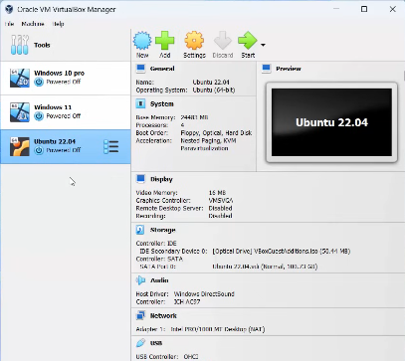
- Click on NEW
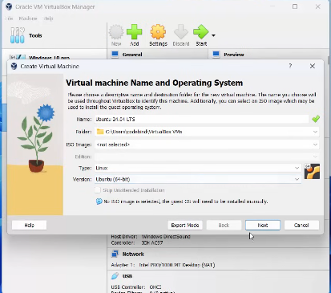
- Give a name
- Select File location
- Click next
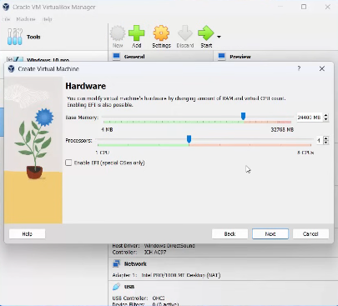
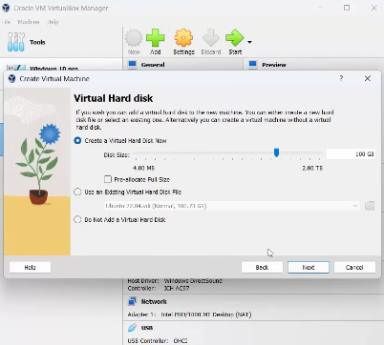

*Step 4: Allocate Memory (RAM)*
1. In the "Memory Size" window, allocate the amount of RAM for your virtual machine. A minimum of 2048 MB (2 GB) is recommended, but you can allocate more if your system allows. 2. Click "Next" to continue.
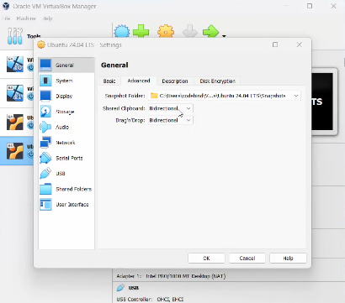
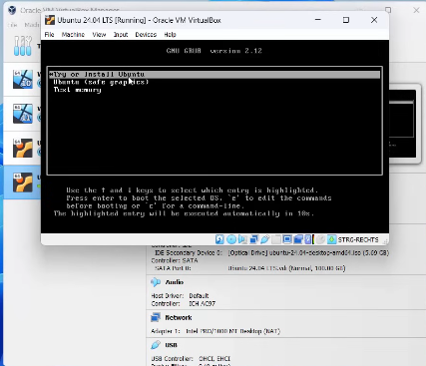

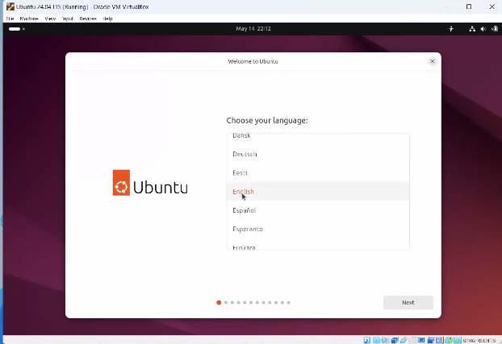
Just do next
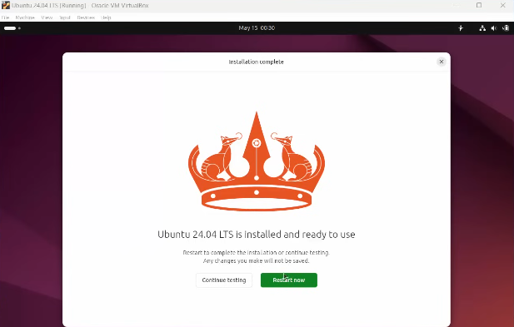
Restart the Ubuntu machine
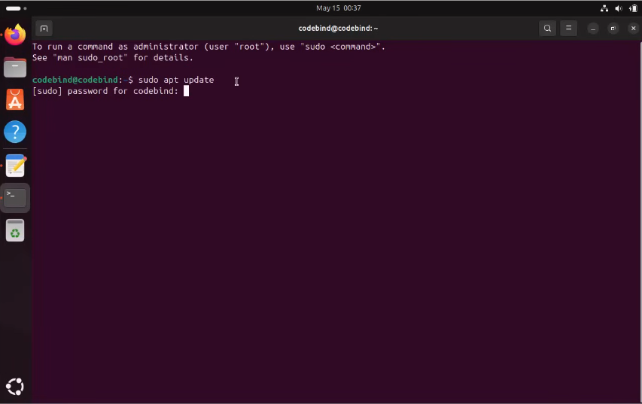
Open terminal and enter the command
sudo apt update
sudo apt install build-essential dkms linux-headers-$(uname -r)
Then restart
